
Medication Adherence Tracker for Elderly Patients
A CASE STUDY ANALYSIS REPORT
Submitted in the partial fulfilment for the Course of
CSA1012-Software Engineering
to the award of the degree of
BACHELOR OF TECHNOLOGY
IN
Artificial Intelligence
Submitted by
P SADVIK(192472243)
Under Supervision of
Dr. k Anita Davamani
SIMATS ENGINEERING
Saveetha Institute of Medical and Technical Sciences
Chennai-602105
AUGUST-2026

1. Study and Analyze the Scenario

1.1 Understanding of the Problem Statement
The assigned problem concerns elderly patients who have to take medicines at different times during the day. When several medicines are prescribed, remembering the correct time and dose becomes difficult. A patient may miss a dose or forget to record it, while a caregiver who lives separately may not know that the dose was missed.
The proposed Medication Adherence Tracker is a software system that connects the patient's medication schedule with a caregiver monitoring function. The patient receives simple reminders and confirms a dose after taking the medicine. The caregiver can enter medication schedules, view adherence information and receive an alert when a dose remains unconfirmed beyond a defined time.

1.2 Business Domain
The system belongs to the healthcare support and digital health domain. Its purpose is medication-management assistance and remote caregiver monitoring. It is not intended to diagnose illness, change prescriptions, or replace professional medical advice.

1.3 Stakeholders
Stakeholder | Role / Interest
Elderly patient | Uses reminders and confirms medication intake.
Caregiver / family member | Creates schedules, monitors adherence and receives alerts.
Healthcare provider | May supply or review medication information where supported.
System administrator | Manages users, roles and system configuration.
Notification provider | Delivers application notifications or alerts.

1.4 Existing Challenges
- Complex medication schedules are difficult to remember.
- Older adults may have limited familiarity with mobile applications.
- Caregivers may live away from the patient and cannot check every dose physically.
- Traditional paper reminders do not provide real-time remote status.
- Delayed awareness of a missed dose can make caregiver response slower.

1.5 System Objectives
- Provide an elderly-friendly reminder interface.
- Allow authorized caregivers to manage medication schedules.
- Record dose confirmations and missed doses.
- Send caregiver alerts after a configured missed-dose threshold.
- Support adherence history and refill reminders.
2. Identify Functional and Non-Functional Requirements

2.1 Functional Requirements
ID | Functional Requirement
FR-01 | The system shall authenticate users before protected functions are accessed.
FR-02 | The system shall support patient and caregiver roles.
FR-03 | The caregiver shall add, edit and remove medication records.
FR-04 | The caregiver shall define dose time, frequency and schedule details.
FR-05 | The system shall generate a reminder when a scheduled dose is due.
FR-06 | The patient shall confirm a dose using a simple interaction.
FR-07 | The system shall store the status and time of each scheduled dose.
FR-08 | The system shall identify a dose as missed after the configured threshold.
FR-09 | The system shall notify the assigned caregiver about a missed dose.
FR-10 | The caregiver shall view adherence history for the patient.
FR-11 | The system shall track remaining medication quantity for refill reminders.
FR-12 | The system shall enforce role-based access to patient information.

2.2 Non-Functional Requirements
Type | Requirement
Usability | Large readable text, clear icons, simple navigation and minimal steps.
Performance | Common screens and actions should respond without unnecessary delay.
Security | Authentication, authorization and secure communication shall protect data.
Reliability | Scheduled reminders and alert processing should operate consistently.
Availability | The service should be available during required medication times.
Maintainability | The system should use modular components and clear documentation.
Scalability | The design should support increasing numbers of patients and caregivers.
Privacy | Only authorized users should be able to view protected patient information.

2.3 Requirement Priorities
The reminder, scheduling, dose confirmation and missed-dose alert functions are core requirements because they directly solve the assigned problem. Adherence history and refill reminders are supporting requirements. External pharmacy or healthcare-provider integration can be treated as a future extension.

3. Identify Actors and Use Cases

3.1 Primary and Secondary Actors
Actor | Type | Main Interaction
Elderly Patient | Primary | Receives reminders and confirms medication intake.
Caregiver | Primary | Manages schedules and monitors adherence.
Healthcare Provider | Secondary | May provide or review medication information.
System Administrator | Secondary | Manages accounts, roles and configuration.
Notification Service | External | Delivers reminders and caregiver alerts.
Pharmacy System | Future External | May support refill information.

3.2 Major Use Cases
- Authenticate User
- Manage Patient Profile
- Add / Edit Medication
- Set Medication Schedule
- Receive Medication Reminder
- Confirm Dose
- Record Missed Dose
- Send Caregiver Alert
- View Adherence History
- Set Refill Threshold
- Receive Refill Reminder
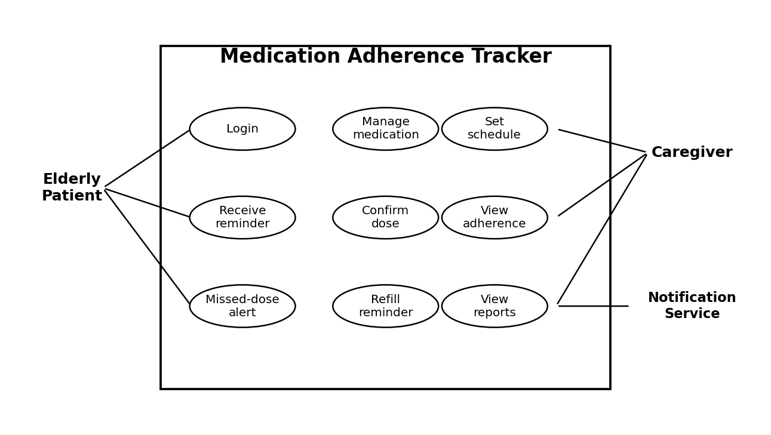
Figure 1. Use Case Diagram of the Medication Adherence Tracker.

3.3 Use Case Relationship
The elderly patient is connected mainly with reminder and confirmation activities. The caregiver has administrative access to medication schedules and monitoring information. The notification service is used by the system when reminders or escalation alerts must be delivered.
4. Prepare the Software Requirement Specification (SRS)

4.1 Introduction
The SRS defines the expected behaviour and quality requirements of the proposed Medication Adherence Tracker. It acts as a common reference for analysis, design, implementation and testing. The requirements are written so that each major feature can later be verified through a suitable test.

4.2 Problem Description
Elderly patients may forget medication times or have difficulty managing several prescriptions. Caregivers may also have limited visibility into whether a patient has taken a scheduled dose. The system addresses this gap by combining medication scheduling, patient reminders, confirmation records and caregiver alerts in one application.

4.3 Scope of the System
- User authentication and role management.
- Medication and schedule management.
- Patient reminders and dose confirmation.
- Adherence status and history.
- Missed-dose escalation to caregivers.
- Medication stock and refill reminders.
- Secure storage and controlled access to patient information.

4.4 High-Level System Context
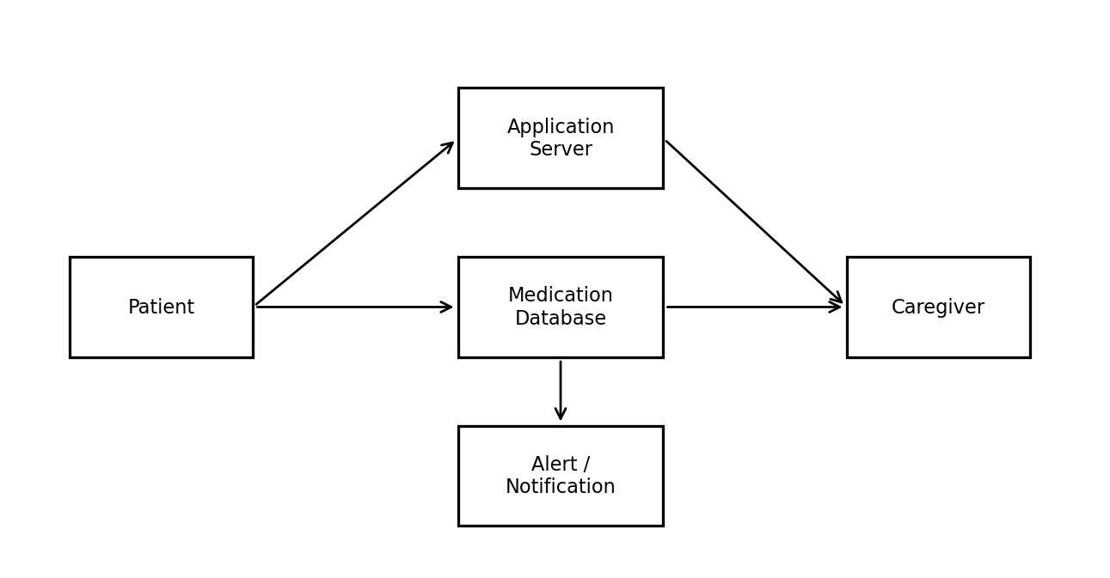
Figure 2. High-Level System Context for the Proposed System.

4.5 System Features
Feature | Expected Behaviour
Patient Dashboard | Shows next dose, reminder and simple confirmation action.
Medication Management | Stores medicine, dose, frequency and schedule.
Reminder Module | Generates reminders according to stored schedules.
Dose Tracking | Stores Taken, Pending and Missed states.
Caregiver Dashboard | Shows current and historical adherence information.
Alert Module | Notifies caregiver after a missed-dose threshold.
Refill Module | Warns when medication quantity becomes low.
Access Control | Limits functions and information according to role.
4.6 Use Case Descriptions

Use Case UC-01: Add Medication
Item | Description
Actor | Caregiver
Precondition | Caregiver is authenticated and has access to the patient.
Main Flow | Open medication management → select patient → enter medication details → set schedule → save.
Exception | If required data is missing or invalid, the system displays an error and does not save the incomplete record.
Postcondition | Medication and schedule are available for reminder processing.

Use Case UC-02: Confirm Dose
Item | Description
Actor | Elderly Patient
Precondition | A scheduled medication is due.
Main Flow | Reminder appears → patient takes medicine as prescribed → patient selects Confirm / Taken → system records confirmation time.
Exception | If no confirmation is received, the dose remains Pending until the missed-dose threshold is reached.
Postcondition | Dose is recorded with a status and timestamp.

Use Case UC-03: Missed Dose Alert
Item | Description
Actor | System and Caregiver
Precondition | Scheduled dose is pending beyond the configured threshold.
Main Flow | System checks deadline → marks dose Missed → creates alert → sends notification to caregiver → records alert status.
Postcondition | Caregiver can view the missed dose and respond according to the patient's care plan.

Use Case UC-04: Refill Reminder
When remaining medication quantity reaches the configured threshold, the system creates a refill reminder. The reminder is visible to the patient and caregiver according to their permissions.
4.7 Data Requirements
Data Entity | Main Data Items
User | User ID, name, role, contact details, authentication information.
Patient | Patient ID, basic profile, caregiver association.
Medication | Medication ID, name, dosage, frequency, instructions, quantity.
Schedule | Schedule ID, medication ID, date/time, repeat pattern, threshold.
Dose Log | Dose ID, scheduled time, confirmation time, status.
Alert | Alert ID, patient, dose, type, time, delivery/status information.
Refill | Medication, current quantity, threshold, reminder status.

4.8 External Interface Requirements
- Patient interface: large text, clear icons and minimal navigation.
- Caregiver interface: medication management, adherence history and alerts.
- Notification interface: connection to an approved notification channel.
- Authentication interface: secure login and role-based access.
- Future integration interface: documented and secured connection to pharmacy or healthcare systems if required.

4.9 Input and Output Requirements
Area | Input | Output
Medication | Name, dosage, time, frequency, quantity | Saved medication schedule
Dose Confirmation | Patient confirmation | Dose status and timestamp
Caregiver Alert | Missed-dose event | Notification / alert
Refill | Remaining quantity and threshold | Refill reminder
Login | Credentials | Authorized session or error message

4.10 System Features Summary
The system combines patient-side reminders with caregiver-side monitoring. The design keeps the patient's interaction short while giving the caregiver enough information to understand whether scheduled doses have been confirmed.
5. Identify Assumptions and Constraints

5.1 Assumptions
- The patient or caregiver has access to a supported device.
- Medication details entered into the system are correct and follow professional instructions.
- The patient can perform a simple confirmation action.
- The caregiver contact information is current.
- Network or notification connectivity is available when an alert is required.
- Users keep their authentication credentials confidential.
- System date and time are configured correctly for scheduled reminders.

5.2 Technical Constraints
- The application requires persistent storage for schedules and adherence records.
- Notification delivery may depend on an external network or notification service.
- Different mobile devices may handle background notifications differently.
- Security controls must be implemented without making the elderly interface difficult to use.

5.3 Operational Constraints
- The application is a medication-support tool and does not replace medical advice.
- Caregivers remain responsible for responding to alerts.
- A confirmation record indicates a user action; it cannot independently prove that a medicine was consumed.
- The missed-dose threshold must be configured according to the intended use case.

5.4 Economic and Time Constraints
For a student capstone implementation, the first version should use practical software components that can be developed and tested within the project schedule. Paid clinical integrations, specialized hardware and regulated healthcare services may be considered later.

5.5 Legal and Privacy Constraints
Medication information should be treated as sensitive information. The system should collect only necessary data, restrict access by role, protect credentials and use secure communication. Notifications should avoid unnecessary exposure of medication details.
6. Validate Requirement Completeness and Consistency

6.1 Requirement Validation
Validation Check | Finding
Stakeholders addressed | Patient, caregiver, administrator and supporting external actors are included.
Functional coverage | Scheduling, reminders, confirmation, alerts, history and refill functions are specified.
Non-functional coverage | Usability, performance, security, reliability, availability, privacy and maintainability are specified.
Actor-use case mapping | Major interactions are mapped in the use case diagram.
Data requirements | Core entities required by the main workflow are identified.
External interfaces | Notification and future integration interfaces are considered.
Assumptions | User, device, connectivity and schedule assumptions are documented.
Constraints | Technical, operational, economic, time and privacy constraints are listed.
Ambiguity check | The system does not make medical decisions or change prescriptions.
Consistency check | Requirements support the original problem statement and objectives.

6.2 Requirement Traceability
Objective | Related Requirements | Verification
Elderly-friendly interface | FR-05, FR-06 + usability | Interface / usability test
Medication scheduling | FR-03, FR-04 | Functional test
Real-time reminders | FR-05 | Reminder test
Caregiver dashboard | FR-09, FR-10 | Dashboard test
Missed-dose escalation | FR-08, FR-09 | Threshold test
Refill reminder | FR-11 | Low-stock test
Data protection | FR-01, FR-02, FR-12 | Access-control test

6.3 Consistency and Completeness Improvements
- Define exact time thresholds during detailed design.
- Specify the notification channel selected for the implementation.
- Add detailed database field constraints before coding.
- Define accessibility checks with representative elderly users.
- Prepare test cases for every functional requirement.
7. Requirement Analysis Summary
The scenario has been converted into a structured Software Requirement Specification following the sequence given in the assessment instructions. The analysis begins with the business problem and stakeholders, then identifies functional and non-functional requirements, actors and use cases. The SRS sections describe scope, system features, data, interfaces and operational behaviour.
The most important requirement is to provide a simple medication reminder process while giving caregivers timely visibility into missed doses. The proposed use case flow ensures that a scheduled dose moves from reminder to confirmation, or to a missed-dose alert when the configured time limit passes.

7.1 Expected Benefits
- Better visibility of medication schedules.
- Simpler interaction for elderly patients.
- Faster caregiver awareness of missed doses.
- A central record of adherence activity.
- Support for refill planning.
- A clear foundation for later pharmacy or healthcare integration.

7.2 Future Enhancements
- Voice-based dose confirmation.
- SMS or automated call escalation.
- Integration with pharmacy refill systems.
- Wearable or smart-pillbox integration.
- Detailed adherence analytics.
- Multilingual patient interface.
- Additional accessibility features for users with vision or hearing difficulties.

7.3 Conclusion
The requirement analysis shows that the Medication Adherence Tracker can address the main difficulties described in the assigned scenario by combining reminders, medication schedules, confirmation records and caregiver alerts. The SRS provides a practical baseline for the next stages of software design and development. Before implementation, detailed UI specifications, database design, API contracts and test cases should be prepared from these requirements.

References
1. Supplied Annexure A – Scenario-Based Requirement Analysis assessment instructions.
2. Assigned problem statement – Medication Adherence Tracker for Elderly Patients with Caregiver Alerts.

